 | Vessel: MT ABC
 | Change over procedure for main engine fuel oil (HFO to LSMGO)
S. No. | Action
Preparation
A1 | Confirm lubricity improver added to LSMGO Tank during last bunkering or later.
A2 | Ensure fuel oil filters (including stand by / bypass filters) in the service line are cleaned and ready to use.
A3 | Calculate the time required for complete change over from HFO to LSMGO using appropriate tools (FOBAS / DNV calculators), with due consideration of the total volume of the system, Sulphur contents of MGO and HFO, and rate of fuel consumption.  Accordingly, start at an adequate duration before reaching the ECA boundary - time between 3-way valve change over and vessel touching ECA boundary should be more than the time calculated by the calculator.
A4 | Drain MGO tanks and confirm that these are free of water.
Change over process
B1 | Reduce the main engine load to 25% - 40% of MCR load (half ahead).
B2 | Change over running auxiliary engine to LSMGO using the dedicated line (separate from Main Engine FO Service Line), if provided.

B3 | Open MGO service tank outlet quick closing valve to M.E. system.  NV-19: MDO service tank- port, E/R 1st platform (behind cconomiser circ pumps) NV-20: MDO service tank- stbd, E/R 1st platform (beside incinerator WO tank)  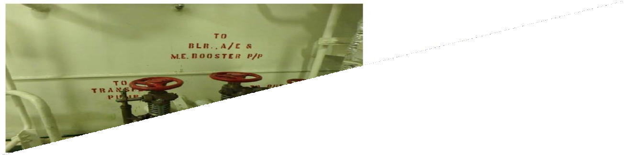
B4 | Close tracing steam inlet valves for M/E fuel oil service line and filters. Location: E/R 2nd deck, HFO service tank (near HFO purifier No 1)  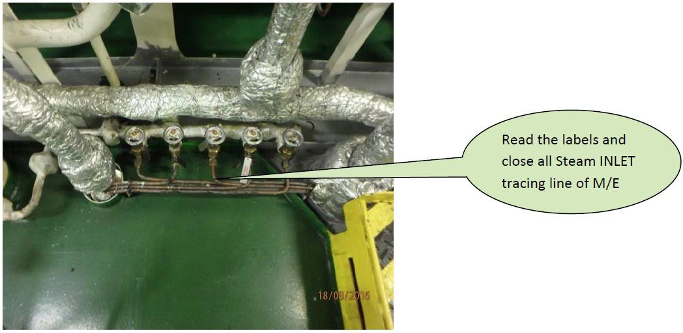

B5 | Close tracing steam outlet valves for M/E fuel oil service line and filters. Location: E/R 2nd deck, HFO service tank (Top side)  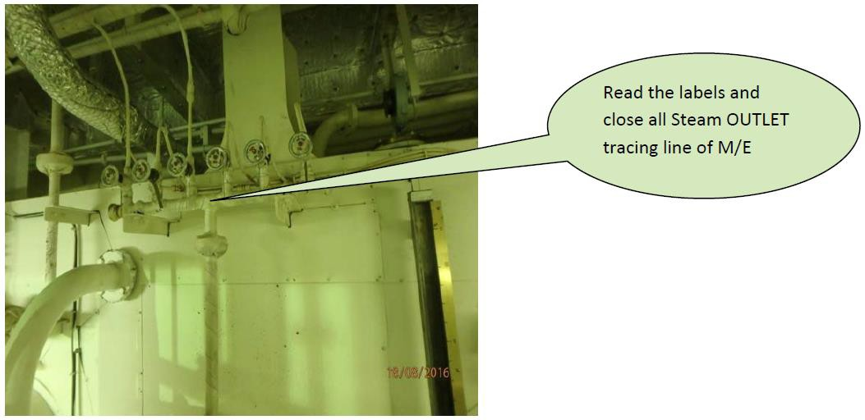
B6 | Change over the visco controller to 'temperature' mode and set the temperature to 85 deg C.  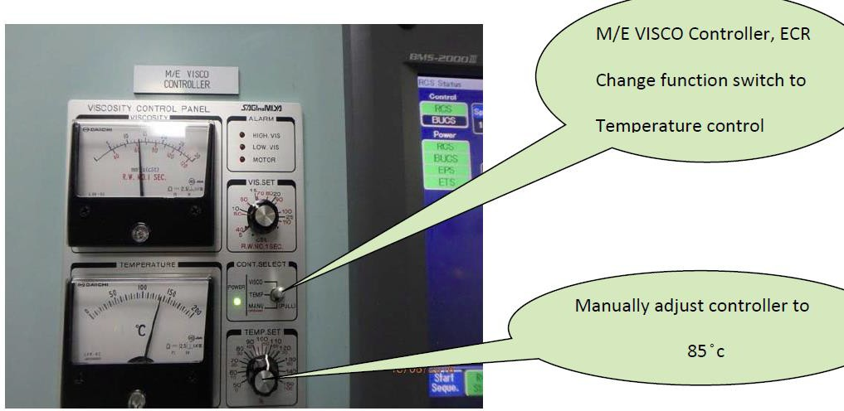
B7 | Visually confirm that automatic steam control valve has begun the process of closing steam.  M/E pre-heater unit location: E/R 3rd Deck  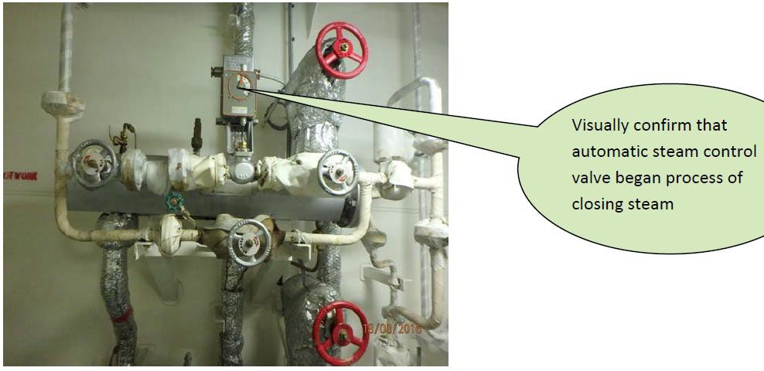

B8 | Monitor temperature change of the main engine fuel inlet. Monitor temperature on the AMS screen, trend No.03  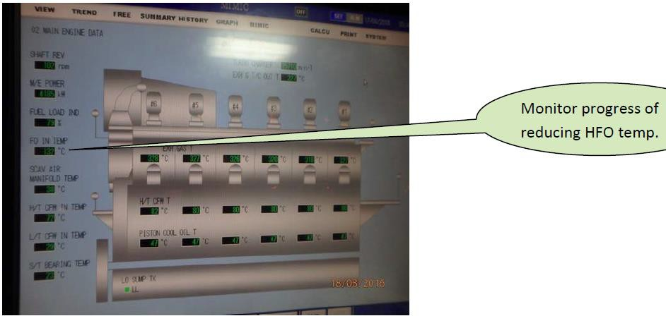
B9 | Monitor fuel oil temperature closely to ensure that temperature reduces gradually (1 to 2 deg. C. / minute).  If it is required to reduce the rate of temperature drop, consider gradual reduction of temperature setting on temperature controller / visco controller - Reduce the setting in smaller steps of 5 to 10 deg. C., if needed.
B10 | When FO temperature comes to around 95 deg C, close manual steam inlet valves for fuel oil heater.  Location: ER 3rd Deck  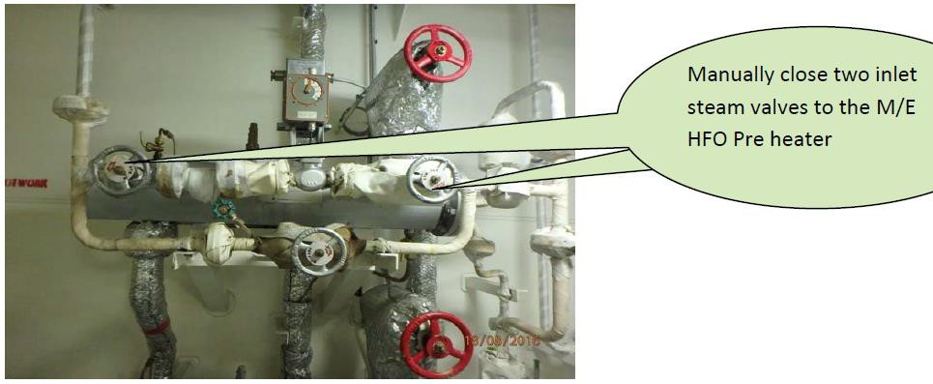

B11 | Close manual steam outlet valves for fuel oil heater. Location: ER 3rd deck  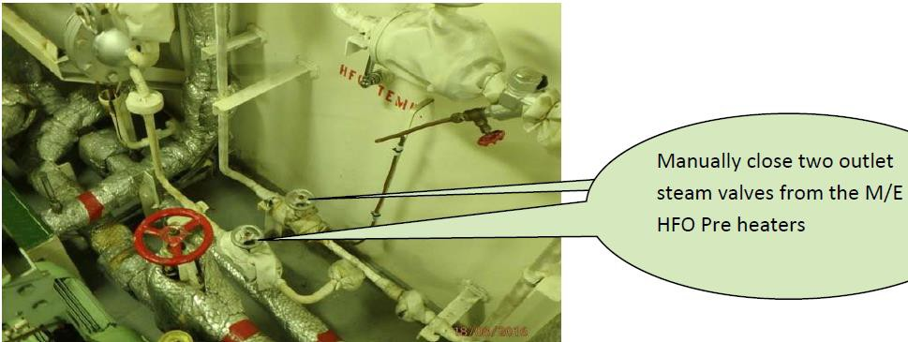
B12 | Open supply line MGO valve (before change over valve / 3-way valve). NV-3: Location: E/R 3rd deck (Near air bottle)  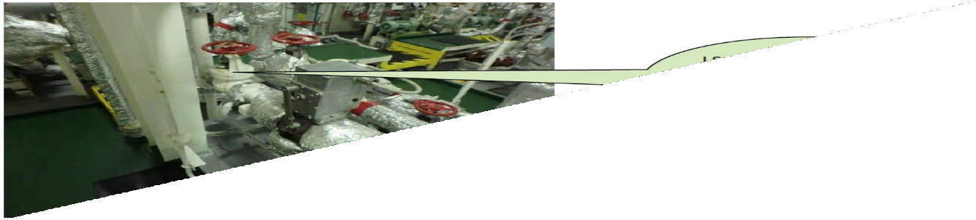
B13 | Change-over 3 way valve from HFO to MGO when FO temperature reaches around 90 deg C.  Location of switch: ECR panel.  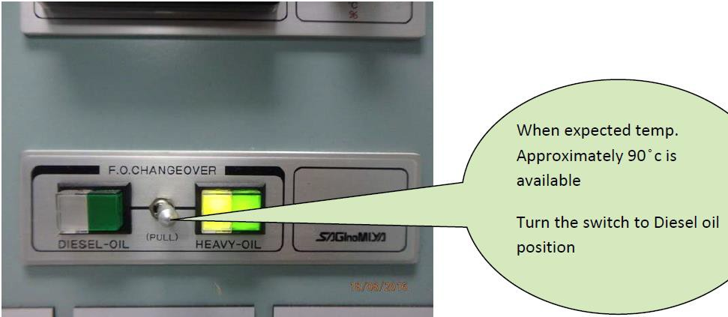

B14 | Confirm that FO change over valve has changed position to 'MGO'. Location: ER 2nd deck / Stbd side  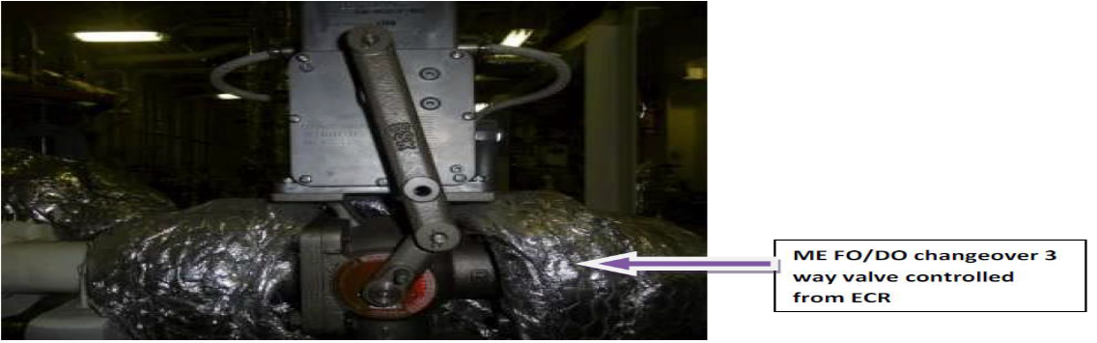
B15 | Record the FO flow meter reading. Location: ER 3rd deck  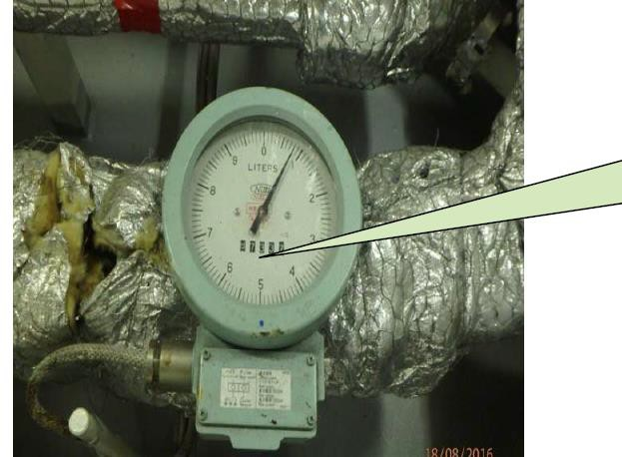
B16 | Close supply line HFO valve (Before change over valve / 3-way valve). NV-10: Location: E/R 3rd Deck (Near air bottle)  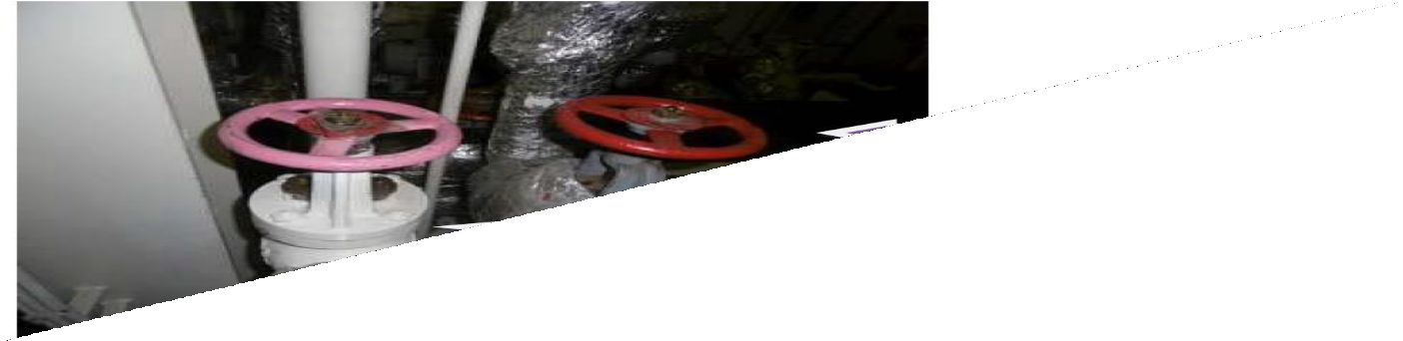

B17 | Close HFO service tank outlet quick closing valves to M.E. system. NV-17: HFO service tank- Port, E/R 1st platform  NV-24: HFO service tank- Stbd, E/R 1st platform
B18 | ME fuel oil inlet viscosity to be closely monitored. MGO will be in the system when viscosity drops below 10 cSt.  Location: ECR panel
B19 | Open the valves to stand by filters (suction side filters and hot filters - AE and ME lines), stand by heater, and stand by pumps (Supply pump, ME circulating pump and AE circulating pump) in FO line, for flushing.  Run the stand by pumps for some time for thorough flushing (displacement of residual HFO).  Stop the stand by pumps, and close the valves for stand by filters and heater after adequate flushing.
B20 | If fuel oil bypass valve is provided for FO heaters, open this valve; and close FO inlet and outlet valves (for FO heater).

B21 | Change over the visco controller to viscosity mode (Viscosity set at 12 to 13 cSt). With LSMGO in the system, this will keep the steam control valve shut, however, viscosity indication will be available continuously.  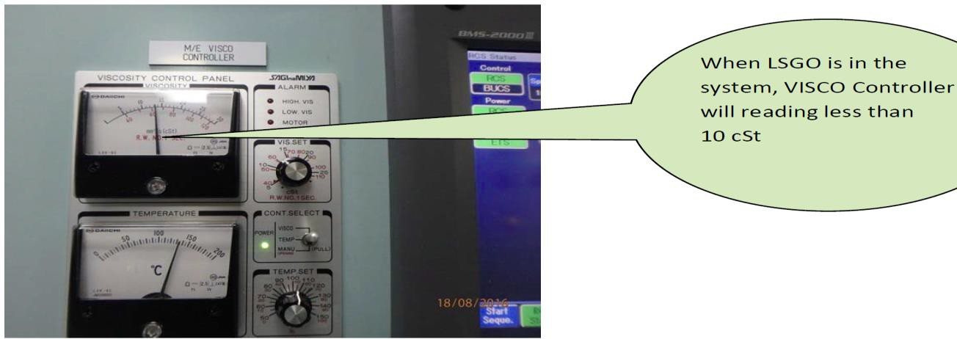
B22 | Line up MGO cooler (If installed).  Plate type MGO cooler (LT Water cooled) to be lined up by opening NV310 (MGO inlet valve), NV 311 (MGO outlet valve), CFV 30 (LT CW inlet valve) and CFV 31 (LT CW outlet valve). MGO bypass valve (NV 312) to be closed.
B23 | Change over cylinder oil consumption to low TBN oil (Maximum 25 TBN for fuel sulphur content < 0.1%).
B24 | Increase main engine RPM to required / service RPM.
B25 | When fuel oil change over is determined to be satisfactorily / stably completed, change over consumption on auxiliary engines to the normal service line (common line from fuel preparation unit).
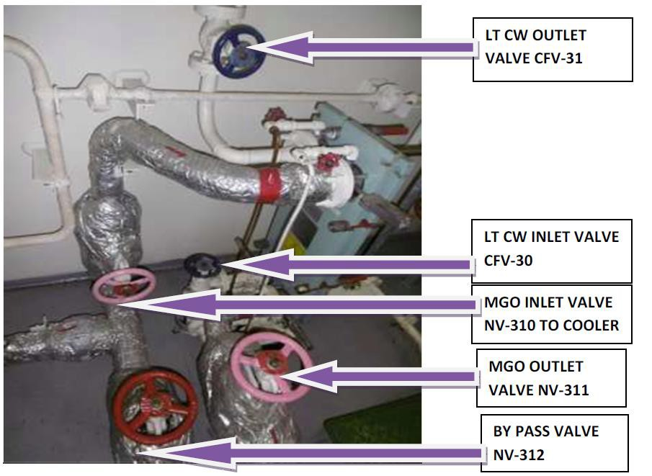

 | Monitoring / Post Change Over Checks
C1 | Close monitoring should be maintained for following parameter / conditions (periodic recording every hour, till conditions are stabilized and normal):  - FO temperature at engine inlet  - FO viscosity  - FO pressure  - FO differential pressure across the filters  - External leakages in the fuel system  - Fuel traces in the sight glass of degasification / vent line of mixing column / degasification chamber  - Sounding of tanks meant to collect fuel leak off as a result of leakages owing to change over to LSMGO (FO drain tank, FO leak off tank, FO overflow tank)
C2 | If fuel oil temperature is unable to be reduced (down to MGO service tank temperature + 5 deg. C., for installations without MGO Cooler) –  - Check for any sources of heat ingress due to leaking steam valves. If required, any steam valves found to be not holding, should be blanked.  - Check that MGO cooler is operating satisfactorily, if provided.

C4 | Drop or fluctuation of fuel pressure could possibly be due to heating and gasification of LSMGO, accompanied with sticking / malfunctioning degasification flap valve (on top of mixing column). Following measures may be needed:  - Checking for sources of heat ingress, and elimination / blanking (as appropriate).  - Isolate mixing column / degasification chamber by closing all connected valves, after opening fuel return to service tank. Drain mixing column, confirm that it is not pressurized, and open the degasification flap valve for checking / servicing.  - Change over to stand by pump (supply pump or circulating pump), to ascertain Pump is operating efficiently / normally.  - If certain pressure regulating valve / relief valve is suspected to be leaking, it may be adjusted or considered for opening for servicing / inspection (after isolation).
C5 | If differential pressure across the filter is observed to increase -  Open up and clean the filter, after lining up the stand by / bypass filter, and isolating.
C6 | Any external leakages should be identified, noted down, and rectified at earliest opportunity.
C7 | If fuel is observed at degasification line sight glass -  Degasification flap valve should be checked / serviced. Prior opening, start fuel return to service tank, isolate mixing column / degasification chamber by closing all connected valves, drain mixing column and confirm that it is not pressurised.
C8 | If fuel leak off has increased (as observed form soundings of the respective tanks) Identify the source of leakage, and rectify at earliest opportunity.
C9 | Monitoring of parameters / conditions (as listed under points C1 to C8) should be maintained routinely, as long as fuel oil system is changed over to MGO.

C10 | Optional - It should be considered to use the opportunity, after complete change over to LSMGO, to carry out performance test on LSMGO (for main engine, auxiliary engines and pumps) in accordance with guidelines for performance test on LSMGO, if the tests are due (or will be due shortly).  For reference, vessels are required to carry out performance tests on LSMGO at frequencies advised below:  - Auxiliary engines ‐ Monthly  - Main engines ‐ Quarterly  - Fuel pumps (supply / circulating / booster pumps) ‐ Quarterly
C11 | Test main engine on both ahead and astern, after complete change over to LSMGO has been accomplished, no more than 12 hours before entering navigable waters, in line with requirements under CFR 164.25 (USCG)
C12 | All FO filters in use, to be cleaned after 6 to 8 hours of change pover to MGO (Example, FO suction filter, Flow meter FO filter, Fuel oil hot filter / Auto backwash filters in both ME and AE service line).
C13 | If MGO cooler is not installed, when the main engine has been stopped, following options may be considered, to prevent FO temperature rise from circulation of oil in the main engine FO system, depending on provisions in the system:  - To stop main engine fuel oil circulating pump. AEs can be supplied either using AE FO circulating pump or the dedicated line (separate from main engine fo service line), if provided.  - To open fuel oil return valve to MGO service tank (if system is provided with a valve for return to MGO service tank), instead of circulating the fuel oil back to FO circulating pump. Before this option is exercised, it should be ensured that fuel line is adequately flushed, and no residual HFO remains in the system. If required, before changing over the return to MGO service tank, return should be directed to HFO service tank for some time to displace any residual HFO to HFO service tank.

